|  |  |  |  |
| --- | --- | --- | --- |
| **Cell type** | **Gene markers** | **Low or lack of expression** | **Protein markers** |
| Celiac rogue | *cd3d, cd8a/cd4, trac, trbc1* | *cd3inter* | CD3+, CD4-, CD8-,clonal TCR |
| CD8 naïve | *cd3d, cd8a/b, tcf7, ccr7, il7r, cd28, cd27, sell* | *cd45ro-, cxcr3-, il2r-, cd58-, cd57-* | CD3, CD8, CD45RA, CCR7, CD62L, CD28, CD27, CD127 |
| CD8 EM (effector memory) | *cd3d, cd8a/b, trbc1, trbc2, trac, ifng, gzmk/h/b/a, ccl4/3, nkg7, tnf, klgr1, cx3cr1* | *cd45ra-, cd27+/- , cd28+/-,ccr7low, sell(cd62l)low* | CD3, CD8, CD45RO, KLRG1,TCRab, CD127+/-,CD28,NKG2D,CD58, CD11a,IL2R |
| CD8 TEMRA  (effector memory re-expressing RA) | *cd3d, cd8a-b, ifng, gzmk-h-b-a, ccl4-3, nkg7, tnf, klgr1, cd45ra* | *cd27-, ccr7-, cd127low* | CD8, KLRG1, TCRab, CD45RA, CD58 |
| CD8 CM  (Central memory) | *cd3d, cd8a-b, ccr7, sell(cd62l), cd27, il7r, eomes, stat3* | *cx3cr1low, tbetlow, cd45ra-* | CD8A,CCR7, CD62L, CD27, CD127 |
| CD8 TRM  (Tissue resident memory) | *cd3d, cd8a-b, cd69, itgae, cxcr3, il7r* | *klrg1low, ccr7low, sell(cd62l)low* | CD8A, CD69, CD127, CD103, CD45RO,CD49a,CXCR3 |
| CD8 PM  (Peripheral memory) | *cd3d, cd8a-b, ccr7+/-, sell(cd62l)+/-, il7r, cd27* | *ccr7+/-, sell(cd62l)+/-,* | CD8A, CD62L, CD127, CD27 |
| CD8 exhausted | *klrb1, pdcd1, tox, tigit, lag3, havcr2, ctla-4* | *tcf1-, ifnglow, tnflow, il2low* | PD-1, CTLA-4, TIM-3, Lag-3, TIGIT, CD160, 2B4, CD7, CXCR5, KLRG1 |
| CD4 naïve | *cd3d, cd4, tcf7, ccr7, il7r, cd28, cd27, sell, ccr3, ccr4* | *cd45ro-, cd44-, hla-dr-, fas-* | CD4, CD45RA, CCR7, CD62L, CD28, CD27, IL7R |
| CD4 EM  (Effector memory) | *cd3d, cd4, tnf, gzmk, gzmh, gzmb, gzma, ifn, ccl4, klrg1*  *cd44?* | *sell(cd62l)low, ccr7low* | CD3, CD4, KLRG1,TCRab, CD45RO,CD69,CD103, CD127,CD28,NKG2D,CD27, CD28,CD58 |
| CD4 TH1  (T helper) | *cd3, cd4, ccr1, ccr5, cxcr3, ifngr1, ifngr2, il12rb2, il18r1, il27ra, stat1, stat4, tbet* |  | CD3, CD4, CD119, CD218a, |
| CD4 TH2 | *cd3, cd4, ccr3, ccr4, ccr8, cxcr4, il4r, il17rb, il1rl1, crlf2, gata3, irf4, stat5, stat6* |  | CD3, CD4, CD124, ST2, TSLP |
| CD4 TH17 | *cd3, cd4, ccr4, ccr6, il1r1, il6r, il21r, il23r, tgfbr2, klrb1, batf, irf4, stat3, rora, rorc2* |  | CD3, CD4, CD121a, CD126, CD360, CD161 |
| CD4 TFH  (Follicular helper) | *cd3d, cd4, btla, b3gat1, slamf5, cxcr4, cxcr5, icos, il6r, il21r, ox40, slam, c-maf, bcl6,* |  | CD45RO, CD44, CD62L, CCR7, CXCR5, ICOS, CD150, CD10 |
| CD4 Tregs | *cd3d, cd4,foxp3,ctla-4, ox40, il2ra, tnfr, tigit, trbc1, entpd1, rtkn2* | *il7rlow* | CD3, CD4,CD25, TCRab, OX40, TIGIT |
| GDv T cells | *trdc,trgc1,trgc2,cd3d, gnly, nkg7, klrd1, ccl3, areg,gzmk,eomes, gata3* | *nkps+/-, cd56+/-*  *cd8- cd4-* | CD3,TCRgd, CD161, |
| CD8+ gd T cells | *cd3d, cd8a, trdc, trgc1, trgc2* |  | CD3, CD8A, TCRgd, CD161, CCR6,CD40,CXCR4,CD16,NKG2D |
| ILC3  (Innate Lymphoid Cell) | *il4i1, rora, ltb, ccr6, ilr7, kit, rorc, ncr2, cd3-* | *cd3-, ilr2low, trac-, trbc-* | CD3-, No TCRab, CD56, CD127, CD117, CD161, CD11b |
| DN MAIT  (Double negative mucosal associated invariant T) | *cd3d, klrb1, il7r, zbtb16, il17a, rorc, tbet, eomes, cd69, itage, gzmb, tnf, ifng* | *cd4-, cd8-,* | CD3, CD69, CD127, CD161, CD103, TCRa7.2, TCRab |
| CD8+ MAIT cells | *cd3d, cd8a, klrb1, il7r, zbtb16, rorc, tbet, eomes,dpp4, tnf,ifng* | *cd27-* | CD3, CD8, CD161, CD69, CD103, CD127, TCRa7.2, TCRab, CD26 |
| NK cells  (Natural Killer) | *klrd1, klrb1,nkg7, prf1, ncr1, ifng, ccl3,-4, klrk1, xcl1, fcer1g, klrf* | *cd3-,il7r-* | NKP46,NKG7,CD16,CD56+/- |
| NKT cells  (Natural killer T cell) | *cd3d, cd8a, prf1, ncr1, ifng, nkg7, ccl3,-4, klrk1, xcl1, tbx21 gata3 zbtb16, klrb1* | *sell(cd62l)-*  *cd56+/-* | CD3+, NKP46, NKG7,CD16, CD56+/- |
| Plasma cells | *igl, igh, cd79a, irf4* | *cd19-, mme(cd10)-, ms4a1low, hla-drlow* | CD19-, CD20, CD38 |
| B cells | *igl, igh, cd19, ms4a1, hladr* | *cd3-, cd4-, cd8-* | CD19, CD20, CD27 |
| Mast cells | *tpsab1, tpsb2, ms4a2, kit, cpa3, egr1* | *lin28a-, itgam-, itgaxlow, hla-drlow/-, itga2-* | CD11b, CD117, CD33 |
| Macrophages | *fcgr1a, cd86,il1b,itgax,hla,irf8* | *cd163-, cd19-, ms4a1-* | CD14, CD16. CD86, CD64 |
| Dendritic cells | *hla-dr, cst3, il1b, cd83, lyz, fcer1g, irf8, cd74* | *lin28a-, cd19-, ms4a1-* | CD83, HLADR |
| Monocytes | *tyrobp, fcer1g, lyz, cst3* | *lin28a-, fcgr3a(cd16)-, cx3cr1-* | CD16, CD14, CD11b, CCR2, |

Note:

+/-: positive or negative

Low/-: low or negative expression

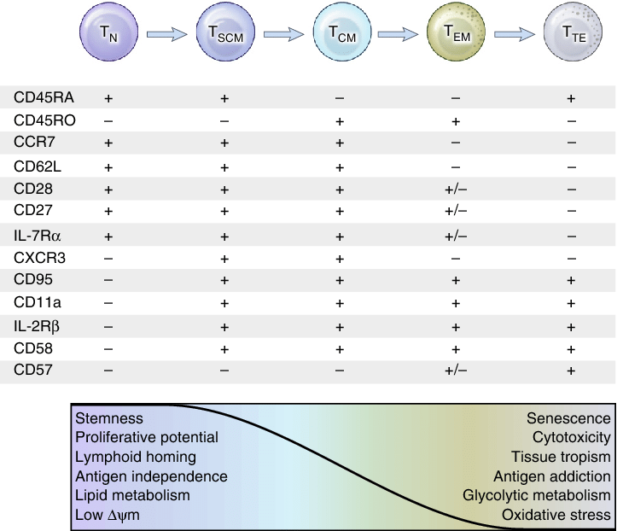

DOI: [10.1038/nm.4241](http://dx.doi.org/10.1038/nm.4241" \t "_blank)

| **ILC Subset** | **Human Markers** |
| --- | --- |
| ILC1 | [CD127](https://www.bio-rad-antibodies.com/cd127-il-7r-antibody-range.html), [CD161](https://www.bio-rad-antibodies.com/cd161-klrb1-nk1-1-antibody-range.html#targetSpecies=Human), [IL-1R1](https://www.bio-rad-antibodies.com/il1r1-cd121a-antibody-range.html#targetSpecies=Human) |
| ILC2 | [CD127](https://www.bio-rad-antibodies.com/cd127-il-7r-antibody-range.html), [CD161](https://www.bio-rad-antibodies.com/cd161-klrb1-nk1-1-antibody-range.html#targetSpecies=Human), [IL-1R1](https://www.bio-rad-antibodies.com/il1r1-cd121a-antibody-range.html#targetSpecies=Human), [CRTH2](https://www.bio-rad-antibodies.com/crth2-gpr44-cd294-antibody-range.html#targetSpecies=Human), ST2 |
| ILC3 – NCR- | [CD127](https://www.bio-rad-antibodies.com/cd127-il-7r-antibody-range.html), [CD117](https://www.bio-rad-antibodies.com/cd117-antibody-marker-range.html#targetSpecies=Human), [CD161](https://www.bio-rad-antibodies.com/cd161-klrb1-nk1-1-antibody-range.html#targetSpecies=Human), [IL-1R1](https://www.bio-rad-antibodies.com/il1r1-cd121a-antibody-range.html#targetSpecies=Human), [IL-23R](https://www.bio-rad-antibodies.com/il23r-antibody-range.html#targetSpecies=Human) |
| ILC3 – NCR+ | [CD127](https://www.bio-rad-antibodies.com/cd127-il-7r-antibody-range.html), [CD117](https://www.bio-rad-antibodies.com/cd117-antibody-marker-range.html#targetSpecies=Human), [CD161](https://www.bio-rad-antibodies.com/cd161-klrb1-nk1-1-antibody-range.html#targetSpecies=Human), [CD336](https://www.bio-rad-antibodies.com/ncr2-cd336-antibody-range.html#targetSpecies=Human), [IL-1R1](https://www.bio-rad-antibodies.com/il1r1-cd121a-antibody-range.html#targetSpecies=Human), [IL-23R](https://www.bio-rad-antibodies.com/il23r-antibody-range.html#targetSpecies=Human) |

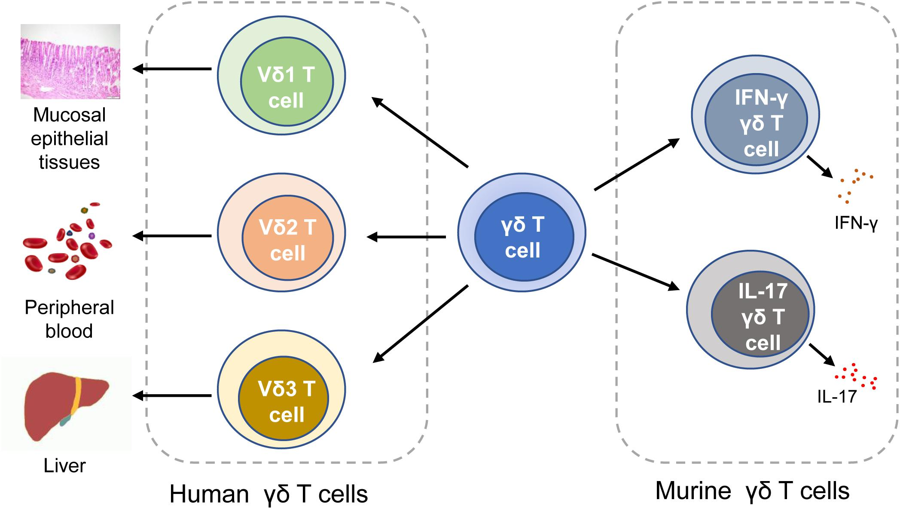

NK Cells

* CD56dim CD16bright (Blood)
* CD56bight CD16dim (tissue)

|  |  |  |  |  |
| --- | --- | --- | --- | --- |
|  | **Marker Expression** | **Cytokine/Chemokine Expression** | **Cellular Activation** | **Biological Function** |
| **HUMAN** | | | | |
| cNK cell | [CD335 (NKp46)](https://www.bio-rad-antibodies.com/nkp46-cd335-antibody-range.html#targetSpecies=Human) [CD94 CD56 (NCAM)](https://www.bio-rad-antibodies.com/cd94-cd314-nkg2-antibody-range.html#targetSpecies=Human&specificitySummary=CD94) | IFN-γ | Activated by secretion of IL-15, IL-12 and IL-18 from DCs, neutrophils, monocytes and macrophages | * Microbe elimination * Tumor eradication * TH1 activation * Inflammatory pathology |
| ieILC1 (CD127-) | [CD335 (NKp46)](https://www.bio-rad-antibodies.com/nkp46-cd335-antibody-range.html#targetSpecies=Human) [CD336 (NKp44)](https://www.bio-rad-antibodies.com/monoclonal/human-cd336-antibody-3-43-mca4665.html) [CD56 (NCAM)](https://www.bio-rad-antibodies.com/cd56-ncam-antibody-range.html) [CD103](https://www.bio-rad-antibodies.com/cd103-antibody-range.html#targetSpecies=Human) | IFN-γ TNF | Activated by secretion of TGF-β, IL-12 and IL-18 from tissue-infiltrating monocytes | * Parasite elimination * TH1 activation * Inflammatory pathology |
| ILC1 (CD127+) | [CD127](https://www.bio-rad-antibodies.com/cd127-il-7r-antibody-range.html) [CD161](https://www.bio-rad-antibodies.com/cd161-klrb1-nk1-1-antibody-range.html#targetSpecies=Human) | IFN-γ TNF | Activated by secretion of TGF-β, IL-12 and IL-18 from tissue-infiltrating monocytes | * Parasite elimination * TH1 activation * Inflammatory pathology |
| ILC2 | [CD127](https://www.bio-rad-antibodies.com/cd127-il-7r-antibody-range.html) [CRTcd74](https://www.bio-rad-antibodies.com/polyclonal/human-cd294-antibody-ahp2174.html) ST2 (IL-33R) | Areg IL-5 IL-13 | Activated by IL-33, IL-25 and TSLP secreted by injured epithelial cells and possibly from a high calorie diet or IL-4 and PGD2 from basophils and mast cells | **Areg producing ILC2s**   * Tissue repair   **IL-5 and IL-13 producing ILC2s**   * Eosinophil recruitment * Mucus production * DC migration to LNs * Type 2 macrophages * TH2 activation |
| ILC3 (NCR-) | [CD127](https://www.bio-rad-antibodies.com/cd127-il-7r-antibody-range.html) [CD117 (c-kit)](https://www.bio-rad-antibodies.com/cd117-antibody-marker-range.html#targetSpecies=Human) [IL-23R](https://www.bio-rad-antibodies.com/il23r-antibody-range.html) | CCL3 LTs IL-22 IL-17 IFN-γ | Activated by CCL20 and IL-23 secretion from epithelial cells and DCs or IL-1β from macrophages via NLRP3 | **CCL3, LTs and IL-22 producing ILC3s**   * TH cell regulation * B cell activation * Macrophage recruitment * Epithelium activation and repair * Intestinal barrier   **IFN-γ and IL-17 producing ILC3s**   * Inflammatory pathology * Tumor rejection |
| ILC3 (NCR+) | [CD127](https://www.bio-rad-antibodies.com/cd127-il-7r-antibody-range.html) [CD117 (c-kit)](https://www.bio-rad-antibodies.com/cd117-antibody-marker-range.html#targetSpecies=Human) [CD336 (NKp44)](https://www.bio-rad-antibodies.com/monoclonal/human-cd336-antibody-3-43-mca4665.html) [IL-23R](https://www.bio-rad-antibodies.com/il23r-antibody-range.html) | CCL3 LTs IL-22 IL-17 IFN-γ | Activated by CCL20 and IL-23 secretion from epithelial cells and DCs or IL-1β from macrophages via NLRP3 | **CCL3, LTs and IL-22 producing ILC3s**   * TH cell regulation * B cell activation * Macrophage recruitment * Epithelium activation and repair * Intestinal barrier   **IFN-γ and IL-17 producing ILC3s**   * Inflammatory pathology * Tumor rejection |

https://www.ncbi.nlm.nih.gov/pmc/articles/PMC2679806/